Hello,

In order to update the bank account we have on file for your payroll and tax filing, please complete the fields highlighted in yellow on the attached form.

Please upload the completed form to the file exchange section of your portal along with a copy of a voided check or a bank letter specifying the routing number, account number, account type and name on the account. Please do NOT email the information back to me as we cannot accept information of this sensitive nature via email.

To upload the information via File Exchange, please follow the steps below.

https://cs.thomsonreuters.com/ua/acct_pr/mypay_client/cs_us_en/solutions/using-file-exchange.htm

- Login to your portal.

- Click on the File Exchange option:
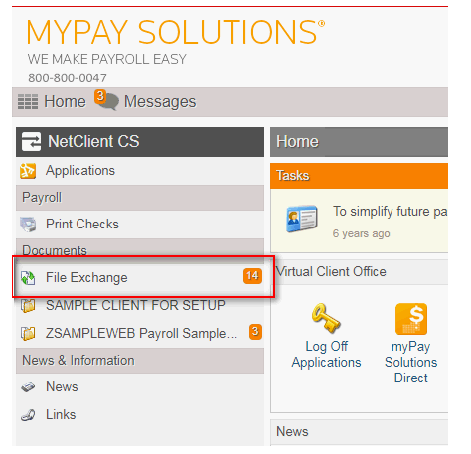

- Once the page loads, click on the folder with your company name:
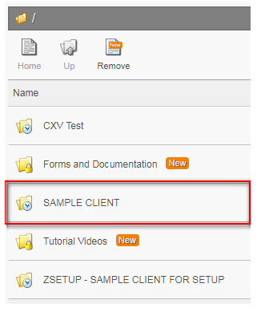

- Click on the UPLOAD icon:
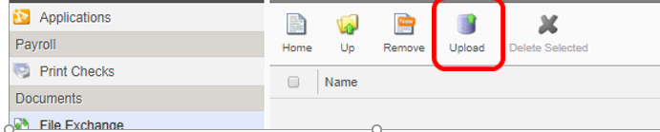

- When the pop up box appears, click on the Add Files option and browse to the location on your pc where you saved the scanned documents.
Select the documents and click Start upload to add them to the portal. I will get a notification that you’ve uploaded the files, but you can also send me a quick email to let me know the upload has been completed.
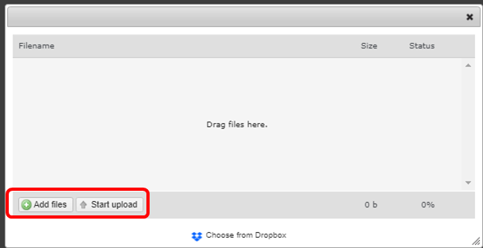

- Please wait to submit your next payroll until you receive confirmation that the change is complete on our end. If there are any questions or clarification needed I will reach out to you directly.

